PHASE 2

Design Document

Programming Project: Database Control with Java



Developed by Jason Chalom 11S

Signoffs
Phase | Teacher | Date | Signature
2) Design Document | Mrs. de Wet

Contents
Design Document 1
1. Summary 2
2. User Interface design 2
a) GUI screen: Main screen, File Menu Opened 2
b) GUI screen: About Screen 6
3. Sequencing 7

1. Summary
My task is to start a business which sells computer components. I have created a database to store, retrieve and do calculations within the database. Now I must create a program which can access that database and display certain information which is important to the business. The program must be user friendly and functional.

2. User Interface design

a) GUI screen: Main screen, File Menu Opened
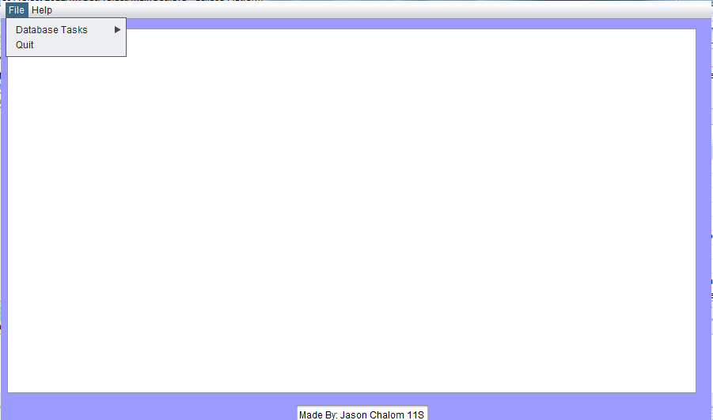
1
2
5
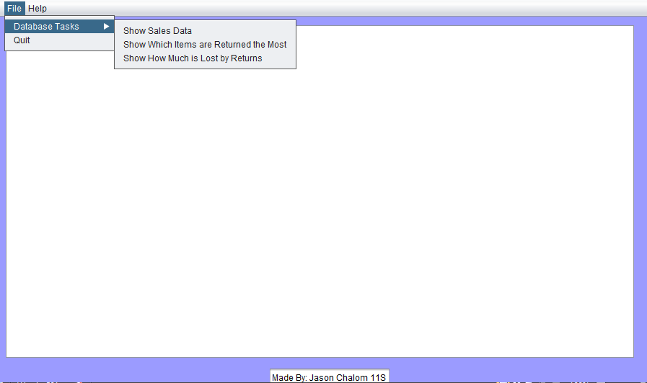
1
2
4
5
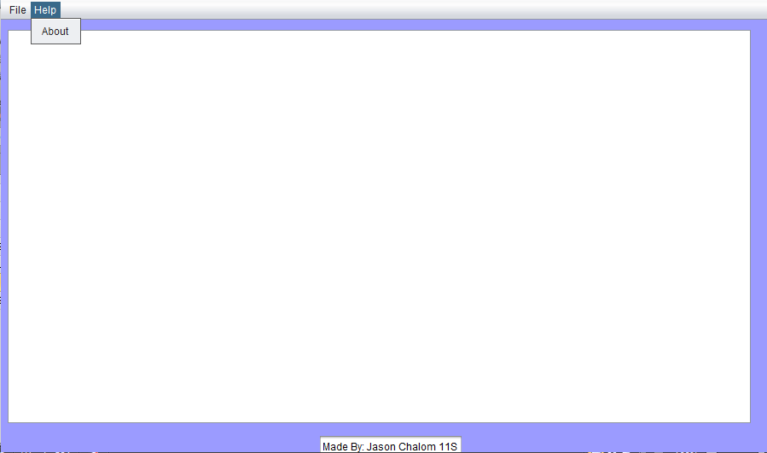
1
3
5
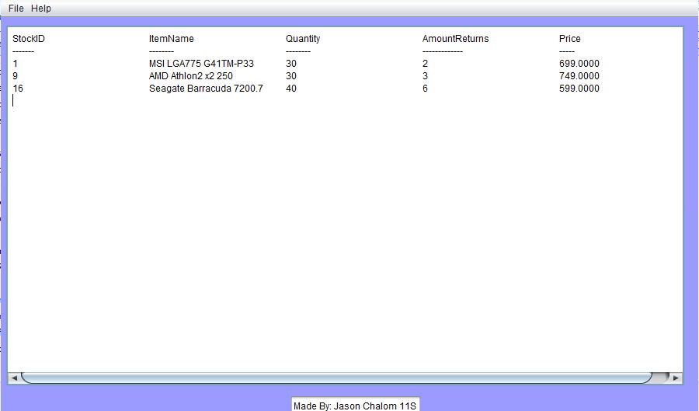
5
6
1
Description | - The screen has a large text area where the data will be displayed. This text area is there so that the data which the program calls up from the database can be viewed by the user.  - This is a file menu item and when clicked a drop down menu will appear.  It is there so that the user can access the functions of the program easily such as the database tasks menu and the quit menu item. When they are clicked it will cause the program to do a function.  The Database tasks menu item, will display another menu when the mouse is placed over it. This menu contains different menu items which when clicked will retrieve data from the database and display it. The quit menu item will exit the program when clicked.  - There is a help menu item on the menu bar and when clicked will display a drop down menu with one menu item which is the about menu item. When the about menu item is clicked it will display a dialog box with information about who made the program, why and how to contact that person.  It is there because if the program starts giving problems or the user does not know how to use the program they can contact the creator of the program and ask for help and support.  - This is the database tasks menu which is opened when the curser is placed over the menu item “database tasks”. This menu contains all the tasks which the program can do with the data in the database which when clicked the program will retrieve and display the data in those specific groupings from the database. The “Show Sales Data” menu item when clicked will retrieve the sales data from all the tables in the database and display the data through the text area.  The “Show which items are returned the most” menu item will retrieve the data on the items which are returned more than once in the database and display the data on that item. The “Show How much is lost by returns” menu item when clicked will retrieve the data from the database and will calculate how much money is lost from returns of stock and then it will be displayed as part of the data in the Text Area for the user to see.  - This is a label which tells the user who wrote the program.  - This is a scroll bar. The whole text area is surrounded by scroll bars and they are shown when the data displayed in the text area exceeds the limits of the text area. They help the user scroll to the data which is out of the bounds of the text area and they help to keep the program user friendly and the data displayed looking neat and ordered.
Security Group | N/A
Data | N/A
Actions | - Click on menu item called File and a drop down menu will appear.  - Place Mouse over the menu item database tasks and another menu will appear.  - Click on the menu item Show Sales Data and the program will display all the relevant sales data in the text area.  - Click on the menu item Show Which items are Returned the Most and the program will display all the item which have been returned more than once with all their relevant data in the text area.  - Click on the menu item Show How Much is Lost by returns and the program will display all the items and will display the information about the number of returns and calculate per item how much in total is lost due to returns.  - Click on the menu item Quit to exit the application.  - Click on the menu item help to open a drop down menu  - Click on the menu item about to open the about box.

b) GUI screen: About Screen

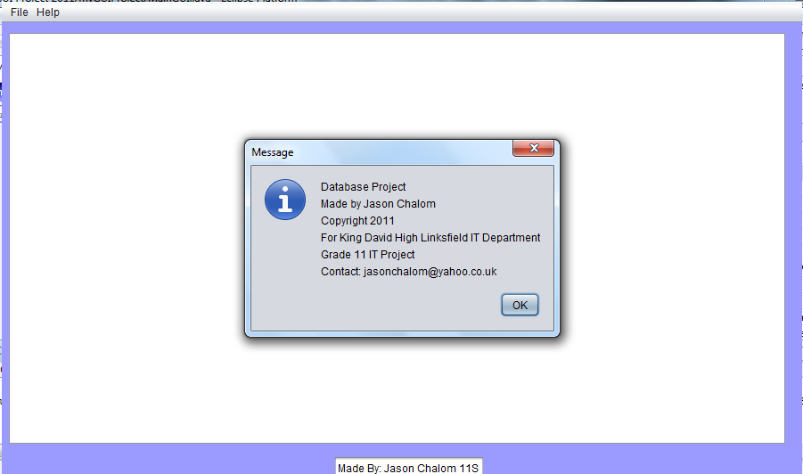
1
2
3
4
5
Description | - This is the about box which appears when the user clicks the about menu item in the help drop down menu.  - This is a logo used on a lot of Java applications to show that the dialog which the user is looking at is a message dialog. This is to show the user that the user must take notice of the information in the about box.  - This is the information which the user can view. It is there to tell the user who wrote the application, for what purpose and how to contact the creator of the program in case there is a problem with the program.  - This is a closing cross on the border of the about menu. When the user clicks it the about box will close. It is there for the user to close the about box when they are done reading it.  - This is an “ok” button which the user can press when they are done to acknowledge that they have taken notice of the information displayed in the about box and to close the about box and go back to the main screen of the program to continue using it.
Security Group | N/A
Data | N/A
Actions | - Click on the OK button to close the about box  - Click on the Red Cross in the right hand corner of the about box to close the about box.

3. Sequencing
- Screen 1 <Main screen>
  - If the user clicks on the file menu
  - If user opens Database Tasks Menu
  - If user selects one of the types of data which the program accommodates for
  - The program determines if an action has been performed
  - If an action has been performed and a SQL event has been selected the program will continue or will wait for an action to happen
  - If an SQL event has been selected by the user then the program will determine which SQL menu item was selected by the user
  - The program will then use the according SQL code to the menu option that the user has selected
    - If the user selected the “Show Sales Data” menu item then this SQL code will be sent into the Databse reading class:
"SELECT tblSales.SalesID, tblSales.ClientID, tblClient.Name, tblSales.StockID, tblStock.ItemName, tblStock.Price, tblSales.AmountPurchases, [AmountPurchases]*[Price] AS TotalSpent FROM tblStock INNER JOIN (tblClient INNER JOIN tblSales ON tblClient.ClientID=tblSales.ClientID) ON tblStock.StockID=tblSales.StockID;
    - If the user selected the “Show Which Items are Returned the Most” menu item then this SQL code will be sent into the Database Reading class:
SELECT tblStock.StockID, tblStock.ItemName, tblStock.Quantity, tblStock.AmountReturns, tblStock.Price FROM tblStock WHERE tblStock.Quantity >10 AND tblStock.Price >= 500 AND tblStock.AmountReturns > 1 ORDER BY tblStock.StockID;
    - If the user selected the “Show How Much is Lost by Returns” menu item then this SQL code will be sent into the Database Reading Class:
SELECT tblStock.StockNo, tblStock.BarCodeNumber, tblStock.ItemName, tblStock.AmountReturns, [AmountReturns]*[Price] AS TotalLost FROM tblStock;
  - The program will send the SQL code into the Database reading class which is called DBCODE.
  - The Database reading class will then create a connection by using the Sun ODBC Driver to the database
  - It will determine if a connection is made and will send a message to the user or it will send an error message to the user if an error occurs.
  - It will then get the metadata from the database according to the SQL Statement sent in and will find the headings of each column
  - It will then get the data from the database according to the SQL statement sent into the class
  - It will then return the data to the main class
  - The data will then be set as the Text Areas text and displayed to the user
  - If no Database Task was selected by the user the application will continue to wait for an action to occur
  - If the user clicks the menu option Quit in the file menu
  - The application will exit
  - If the user clicks on the help menu
  - If user clicks on the About menu item
  - The application will open a JOptionPane Dialog box with information about the creator of the application
- Screen 2 <About Box>
  - The About Dialog Box will Contain the Following Information:
    - Who made the program
    - Why was it made
    - What year was it made
    - Who is it copyrighted to
    - How to contact the creator of the application
  - If the user presses the OK button the About Dialog box will close
  - If the user presses the Cross in the right hand corner of the about box it will close.

